**Biochemistry 2**

**ORGANIC COMPOUNDS**

***Organic compounds*** *are compounds that contain* ***carbon****. There are four types:* ***carbohydrates****,* ***lipids****,* ***proteins****, and* ***nucleic acids****.*

**Carbohydrates:**

***• Carbohydrates*** *consist of only three elements:* ***carbon****,* ***hydrogen****, and* ***oxygen****.****• 4 Calories*** *per gram.****• Carbohydrates supply quick energy.******• There are three classes of carbohydrates:*** *–* ***Monosaccharides*** *–* ***Disaccharides*** *–* ***Polysaccharides***

**MONOSACCHARIDES**  
*• All monosaccharides have the chemical formula* ***C₆H₁₂O₆****.  
• Examples include* ***glucose****,* ***galactose****, and* ***fructose****, which are all* ***isomers*** *of each other.  
•* ***Isomers*** *are compounds with the same molecular formula but different structures.*

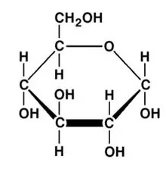

**DR SALMA KHALED BIOLOGY EDUCATOR**

**DISACCHARIDES**  
*• All disaccharides have the chemical formula* ***C₁₂H₂₂O₁₁****.  
• They consist of* ***two monosaccharides*** *joined by a process known as* ***dehydration synthesis****.  
• The following diagram (not shown) demonstrates three dehydration synthesis reactions of monosaccharides.  
• These reactions produce three disaccharides —* ***maltose****,* ***lactose****, and* ***sucrose*** *— along with* ***water*** *as a by-product.*

**Monosaccharide + Monosaccharide → Disaccharide + Water**  
This is the **general equation** for the synthesis of disaccharides.

**Examples of Disaccharide Formation:**

• **Glucose + Glucose → Maltose + Water**  
• **Glucose + Galactose → Lactose + Water**  
• **Glucose + Fructose → Sucrose + Water**

**Hydrolysis** is the **opposite** of dehydration synthesis.  
It is the **breakdown of a compound** with the **addition of water**.  
This process occurs during **digestion** and is the **reverse** of dehydration synthesis.

**Sucrose + Water → Glucose + Fructose**

**Dehydration Synthesis = Build**  
"It builds and forms bonds"

**Hydrolysis = Break**  
"It breaks down in digestion"

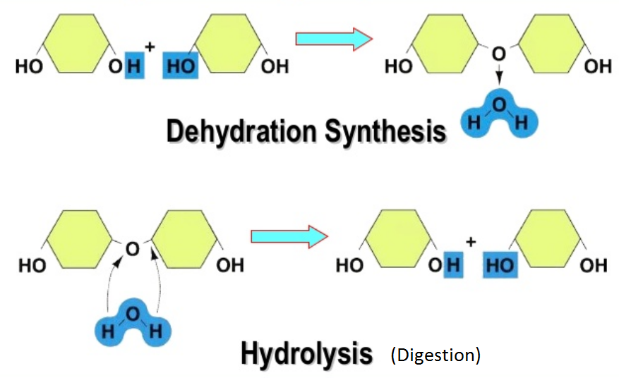

**DR SALMA KHALED BIOLOGY EDUCATOR**

**POLYSACCHARIDES**  
• Polysaccharides are **polymers of carbohydrates**.  
• They form when **many monosaccharides** are joined together through **dehydration synthesis**.

|  |  |  |
| --- | --- | --- |
| **Found in plants** | **Cellulose** | **Starch** |
|  | Plant cell walls | Plant carbohydrates |
| **Found in animals** | **Chitin** | **Glycogen** |
|  | Makes up the exoskeleton in arthropods.  Found in fungi cell walls. | Animal starch |

**LIPIDS**

• Provide **9 calories per gram**  
• Made of **one glycerol** (an alcohol) and **three fatty acids**

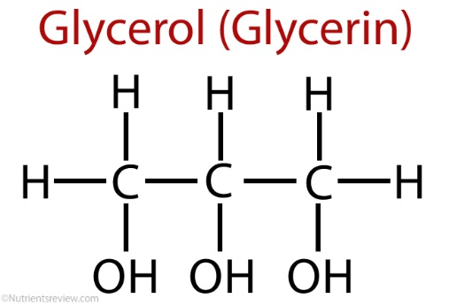 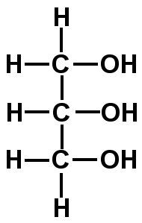

**DR SALMA KHALED BIOLOGY EDUCATOR**

**Fatty Acids**  
• A **fatty acid** is a **hydrocarbon chain** with a **carboxyl group** at one end.  
• Fatty acids come in **two types**:  
 – **Saturated**  
 – **Unsaturated**

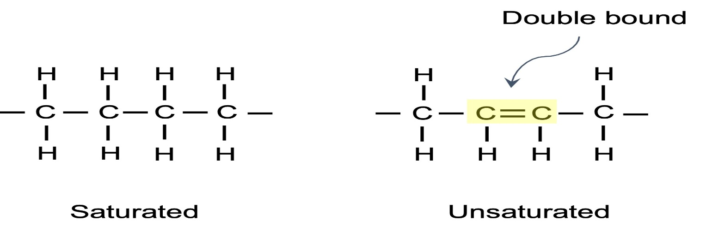

**SATURATED FATS**

• Come from **animals**  
• **Solid** at room temperature  
• Linked to **heart disease** when eaten in large amounts  
• Example: **Butter**  
• Contain **only single bonds** between carbon atoms

**UNSATURATED FATS**

• Extracted from **plants**  
• **Liquid** at room temperature  
• Considered **"good dietary fats"**  
• Have **at least one double bond** in the hydrocarbon chain → **fewer hydrogen atoms**  
• **Monounsaturated** = one double bond  
• **Polyunsaturated** = more than one double bond

**DR SALMA KHALED BIOLOGY EDUCATOR**

**PROTEINS**

• Proteins are **polymers (polypeptides)** made of repeating units called **amino acids**, joined by **peptide bonds**  
• They are **complex macromolecules** responsible for **growth** and **repair**  
• Provide **4 calories per gram**  
• Made of the elements: **S, P, C, O, H, and N** *(Sulfur, Phosphorus, Carbon, Oxygen, Hydrogen, Nitrogen)*  
• With just **20 different amino acids**, cells can build **thousands of different proteins**

• Proteins act as **enzymes**, **membrane channels**, and **hormones**

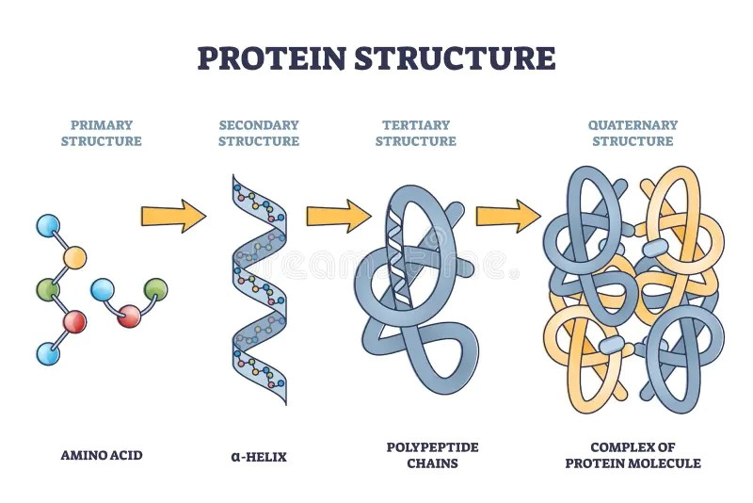

**DR SALMA KHALED BIOLOGY EDUCATOR**

**PROTEIN STRUCTURE**

• **Primary Structure** – The sequence of **amino acids** in the protein chain  
• **Secondary Structure** – Caused by **hydrogen bonding** within the molecule  
  – *Example: The helical shape of proteins*  
• **Tertiary Structure** – The **complex 3D shape** of a protein that determines its **function**  
  – **Enzymes denature** (lose their shape) at **high temperatures** or **extreme pH**  
  – A denatured enzyme **cannot function** because its **tertiary structure is damaged**  
• **Quaternary Structure** – Applies to proteins made of **more than one polypeptide chain**  
  – *Example: Hemoglobin, which has four chains*

**DR SALMA KHALED BIOLOGY EDUCATOR**

**ENZYMES**

• **Enzymes are large proteins**  
• They **speed up chemical reactions** by **lowering activation energy (Ea)** – the energy needed to start a reaction  
• The **active site** is where the **substrate** binds to the enzyme  
• A **substrate** is the chemical that an enzyme acts on  
• **Enzymes are specific** – only one type of substrate fits one enzyme  
• **Enzymes are not used up** in a reaction – they can be **reused**  
• Enzymes are named after their substrate and usually end in **"ase"**  
 – Example: Sucrase breaks down sucrose  
• Enzymes often need help from:  
 – **Cofactors** (minerals)  
 – **Coenzymes** (vitamins)  
• The overall reaction is called a **decomposition reaction**  
• The most important cofactor: **Iron (Fe)** – used in many enzyme systems, including ACT (electron transport, etc.)

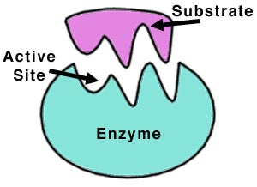

**DR SALMA KHALED BIOLOGY EDUCATOR**

**Induced-Fit Model (How Enzymes Work)**

• The **induced-fit model** explains how enzymes work  
• When the **substrate enters the active site**, it causes the enzyme to **change its shape slightly**  
• This slight change helps the substrate **fit better**  
• The older **"lock and key" model** was replaced because it suggested the enzyme's shape **never changes**, which isn't true

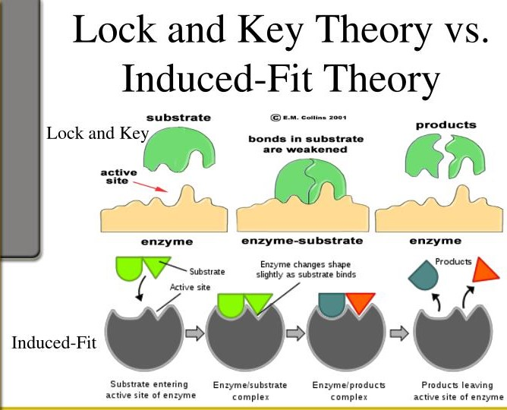

**Factors Affecting Enzyme Efficiency**

• **Temperature** and **pH** affect enzyme activity  
• The **average human body temperature** is **37°C**, which is **near optimal** for most human enzymes  
• If the temperature rises above **40°C**, enzymes begin to **denature** (lose shape) and **stop functioning**

**DR SALMA KHALED BIOLOGY EDUCATOR**

**• As enzymes denature, they lose their unique shape and their ability to function.**

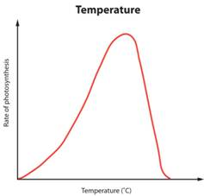

**• Gastric enzymes become active at low pH when mixed with stomach acid.  
• In contrast, intestinal amylase works best in an alkaline environment.**

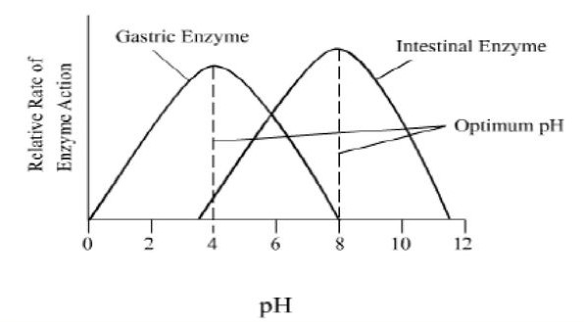

**DR SALMA KHALED BIOLOGY EDUCATOR**

**NUCLEIC ACIDS**

**• The two types of nucleic acids are DNA (*Deoxyribonucleic acid*) and RNA (*Ribonucleic acid*)  
• They carry hereditary information and are made of nucleotides  
• Nucleic acids are polymers of nucleotides**

**Each Nucleotide Is Made of:**

**• A phosphate group  
• A 5-carbon sugar:  
 – Deoxyribose in DNA  
 – Ribose in RNA  
• A nitrogenous base**

**Nitrogenous Bases:**

**In DNA: In RNA:  
• Adenine (A) • Adenine (A)   
• Cytosine (C) • Cytosine (C)  
• Guanine (G) • Guanine (G)  
• Uracil (U) *(replaces thymine) • Thymine (T)***

**Base Types:**

**• Purines: Adenine & Guanine  
• Pyrimidines: Cytosine, Thymine, & Uracil**

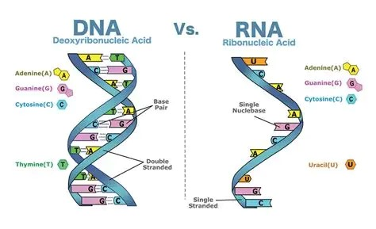

**DR SALMA KHALED BIOLOGY EDUCATOR**